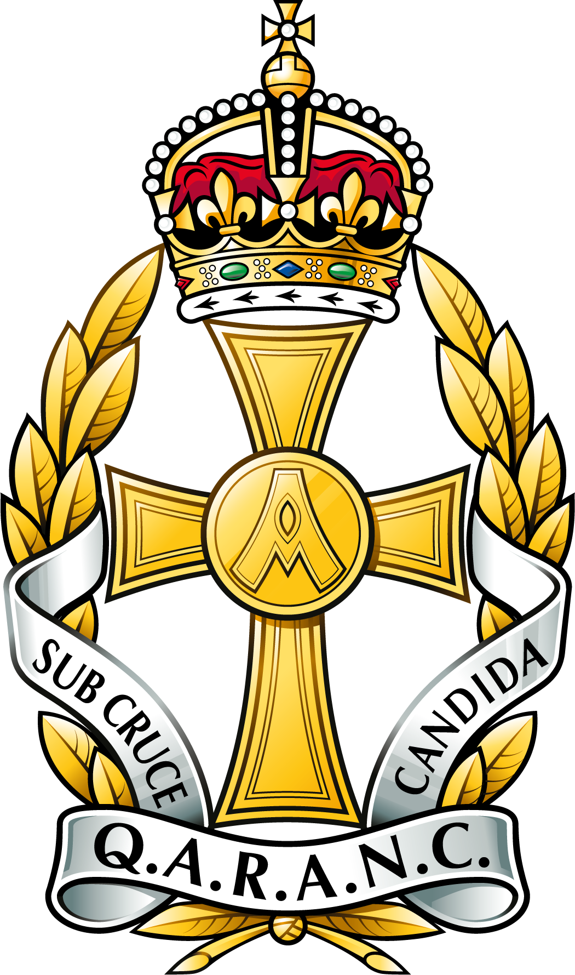 | QUEEN ALEXANDRA’S ROYAL ARMY NURSING CORPS ASSOCIATION |  |  |  |  | 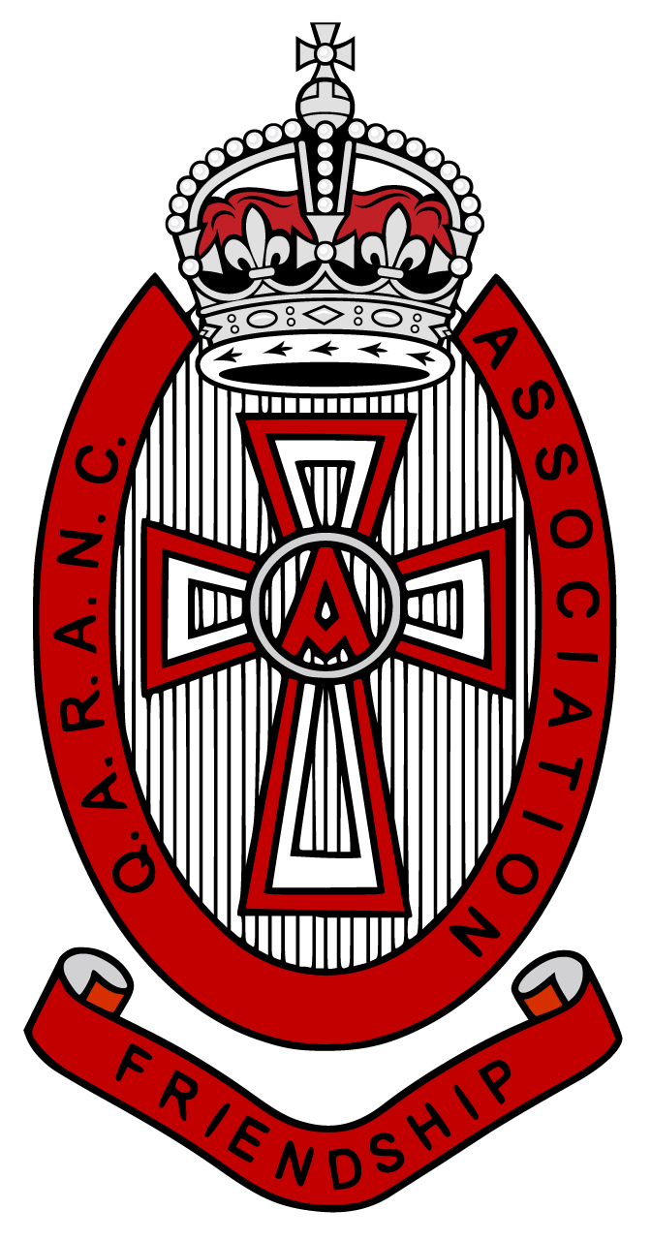
Charitable Incorporated Organisation
Charity Registration Number 1163821
QARANC Association Main Office
Headquarters Army Medical Services
Slim Road
CAMBERLEY
GU15 4NP

 | Telephone: | 07545155489
 | Email: | manager@qarancassociation.org.uk
All Guests |  |  |  | Date: 21 Mar 24

QARANC ASSOCIATION REUNION LUNCH 2024 – 27 APRIL 2024

Introduction

1. On behalf of the Chair and President of the QARANC Association thank you for applying to attend the 2024 Reunion Lunch. This year has seen an overwhelming response and there will be circa 180 attending. So in order to try and make sure the day runs as smoothly as possible please find below details for the Reunion Lunch.

Location

2. The QARANC Association 2024 Reunion Lunch will be held at the following location:

The Grand Hotel Birmingham
1 Church Street
Birmingham
B3 2HE

Details for The Grand Hotel can be found at Hotel in Birmingham | The Grand Hotel Birmingham.
The lunch will be held in The Ballroom and details will be signposted on arrival in the hotel foyer.

Timings.

3. The following is a brief outline of timings:

1100 Registration in the foyer of The Ballroom

1100 Bar open to purchase drinks (card accepted only)

1155 All guests to be seated

1200 Updates from Executive Team

1240 Break to purchase drinks

1300 Seated for lunch

1530 – 1600 Lunch complete

1700 Bar Closes
Travel

4. Most guests by now will have made travel arrangements however it is suggested that attendees travel by public transport. There are good rail links into New Street Station, Station Street, B2 4QA or Snow Hill Station, Colmore Row, B3 2BJ and via coach into Birmingham Coach Station, Mill Lane, B5 6DD. There is no parking at the Hotel; however local car parks are:

B4 Car Park - Weaman Street, B4 6DG. Hotel guests benefit from 55% discount at B4 Car Park – you will need to register with the hotel reception on arrival.

Snow Hill Multi-Storey Car Park - B3 2BJ, is another option but not at a discounted rate.

Other Details

5. QARANC Association Pin Badge. The new QARANC Association lapel pin badge with the Kings Crown will be available to purchase on the day. This will be £5 and is a cash only purchase. So if you intend to purchase one please ensure you have some cash with you.

6. Photographs. We would welcome with your permission that any photos taken on the day at the lunch are shared with us for use on our social media pages and in other presentations or publications. Any photos you wish to share after the event are to be forwarded to manager@qarancassociation.org.uk

Points of Contact

7. If you have any questions then please contact us on:

a. Event Co-ordinator: Administration Manager: Tracey Buckingham ARRC manager@qarancassociation.org.uk

b. Event Support: Administration Officer: Alison Roberts admin@qarancassociation.org.uk

8. Finally we look forward to seeing you on 27 April for the 77th Reunion Lunch in the 75th year of the QARANC. So there is a great deal to celebrate and time to catch up with friends past, current and present.

Safe travels to Birmingham.

In friendship

Tracey Buckingham

Tracey Buckingham ARRC
Administration Manager

