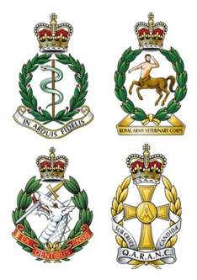
Brigadier AP Finn KHP
Head of Army Healthcare & Head of Army Medical Services
Army Headquarters, Blenheim Building, Marlborough Lines,
Monxton Road, ANDOVER, Hampshire, SP11 8HT

Skype: +443001567845
Mobile: 07796 938754
E-Mail: Antony.Finn584@mod.gov.uk

10 April 2024

To the serving Regular and Reserve personnel, and to the Veteran communities, of the four Corps of the AMS,
The Army has been actively and deliberately considering the benefits of a possible amalgamation of the Royal Army Medical Corps, Royal Army Veterinary Corps, Royal Army Dental Corps and Queen Alexandra’s Royal Army Nursing Corps, collectively known as the Army Medical Services. This work is known as Project VICTORIA with the Assistant Chief of the General Staff as the Senior Responsible Officer. In 2022 the Executive Committee of the Army Board decided that the Royal Army Veterinary Corps would remain an independent Corps for legal and operational reasons. The focus then moved to the three human healthcare Corps. These discussions have involved senior serving members of each Corps and the respective Colonels Commandant and are at an advanced stage. However, no final decisions have been taken.
We would like to reassure everyone with an interest in this process that the needs of our serving community and the views of our veteran communities have been taken into account at all stages through a variety of representatives. In a rapidly changing context for both Defence and Healthcare, making sure that we have the right structures and processes in place to care for our patients and support the Army, building on the heritage we share, has been paramount in all our discussions. It is vital that we make sure that we remain an attractive, modern, and welcoming employer for those who are willing and able to deliver healthcare in difficult and frequently dangerous places well beyond the next decade.
Nothing we have discussed has negated any of your service to date, nor has it looked to weaken or remove the link between those serving now, and those who will serve in the future, with those who served, caring for the Army’s patients, in the past.
Following a period of open consultation our discussions have been held in a fully representative council to ensure we could have the conversations we needed to have and to enable any essential preparatory work to progress at pace without getting ahead of any formal decisions. You will understand that these decisions do not all rest with us. As soon as we are able to announce something, we will.
Thank you for your patience.

Brigadier A P Finn

