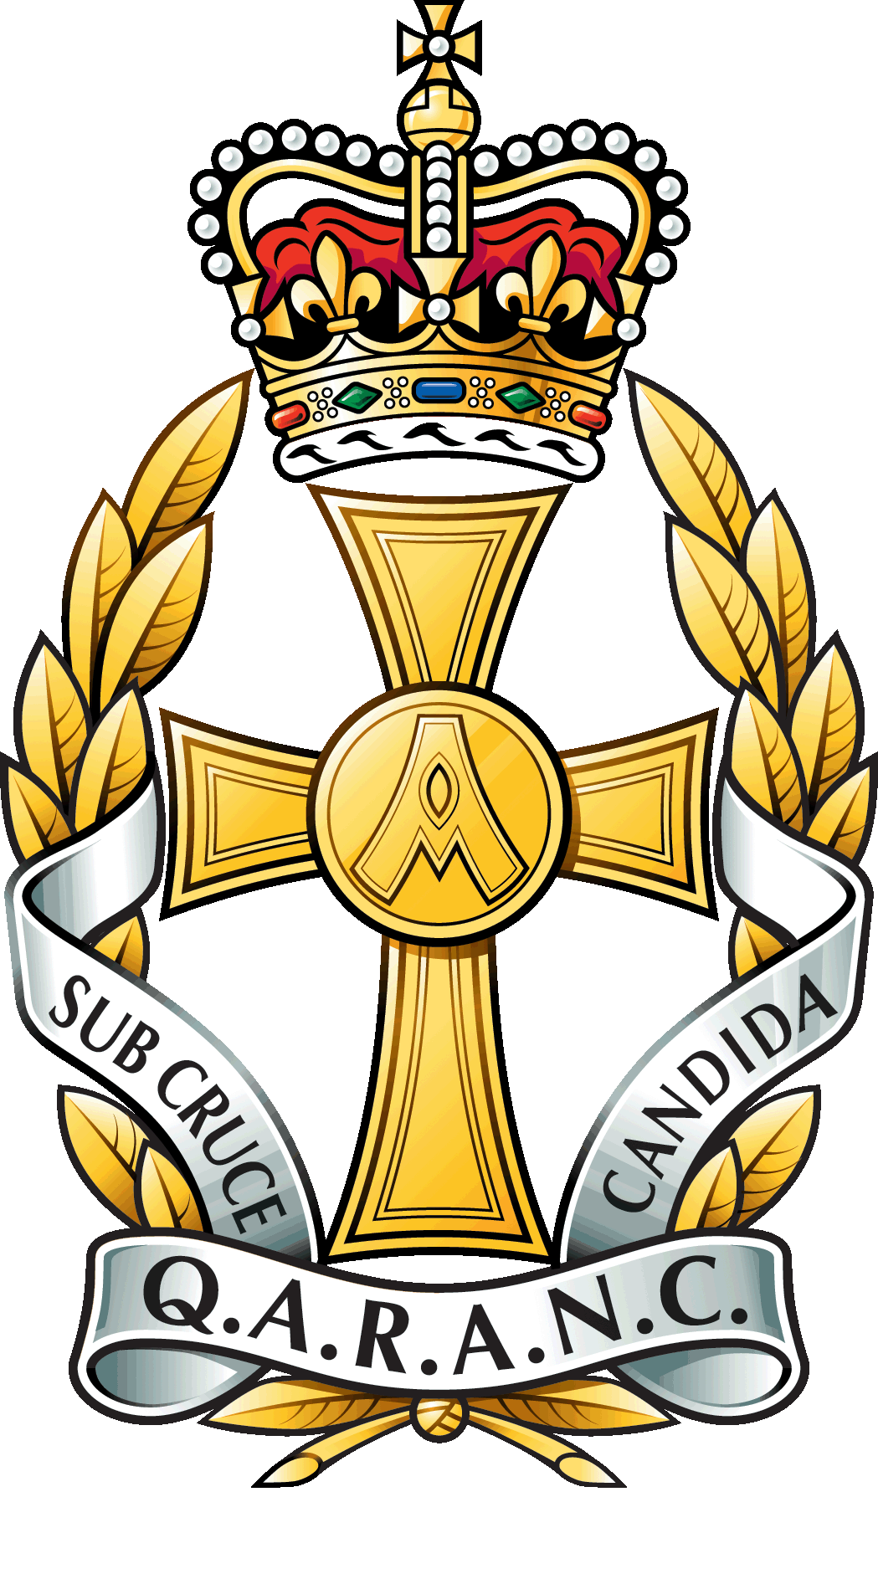 | QUEEN ALEXANDRA’S ROYAL ARMY NURSING CORPS ASSOCIATION |  |  |  |  | 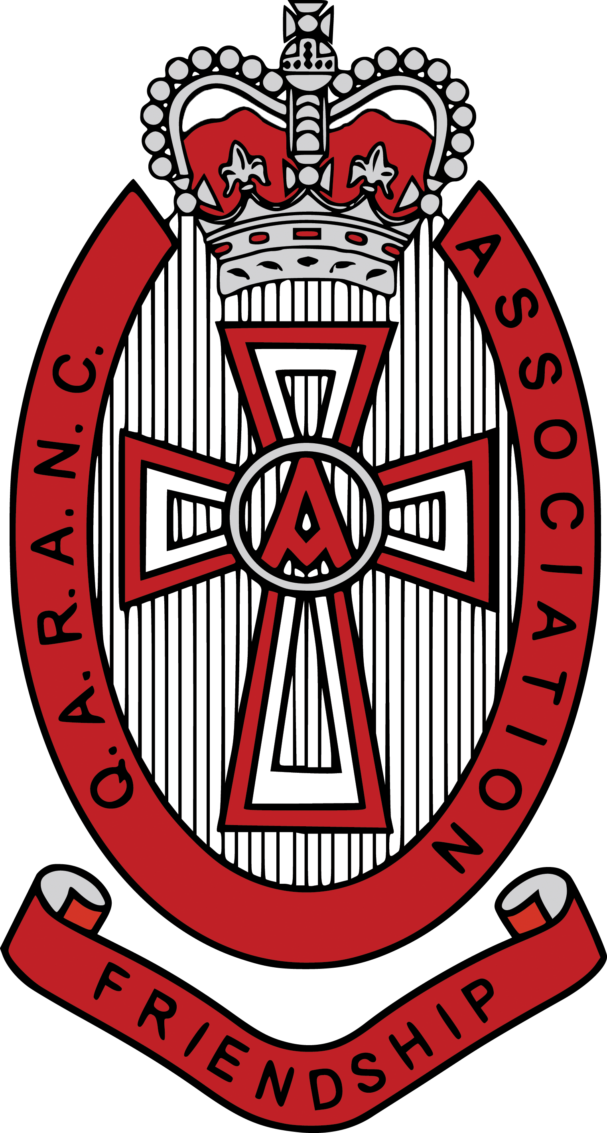
Charitable Incorporated Organisation
Charity Registration Number 1163821
QARANC Association Main Office
Headquarters Army Medical Services
Slim Road
CAMBERLEY
GU15 4NP

 | Telephone: | 07545155489
 | Email: | manager@qarancassociation.org.uk
 |  |  |  | Ref: Awards/2024/04/Branch
All Branches |  |  |  | Date: 21 Nov 23

QARANC ASSOCIATION ANNUAL AWARD 2024

Introduction

1. The QARANC Association Medal is awarded annually to the QARANC Association retired member who has made an outstanding contribution to the Association by fostering esprit de corps, comradeship, and the welfare of the Corps, preserving its traditions or relieving need, hardship, or distress. The prize is funded by the QARANC Association and consists of a medal and a purse of £150.

2. The presentation of the Medal will take place at the Annual Reunion lunch on Saturday 27 April 2024.

Nominations

3. We would like to encourage nominations from individual members of the Association or from branches. Citations submitted from the 2023 award will not be automatically considered but can be updated and resubmitted. All citations must be on the approved form and should reach the Main Office, preferably via email, by Friday 23 February 2024.

4. Submission for the award may be made via the following link or QR Code:

- MS Forms Link

- QR Code

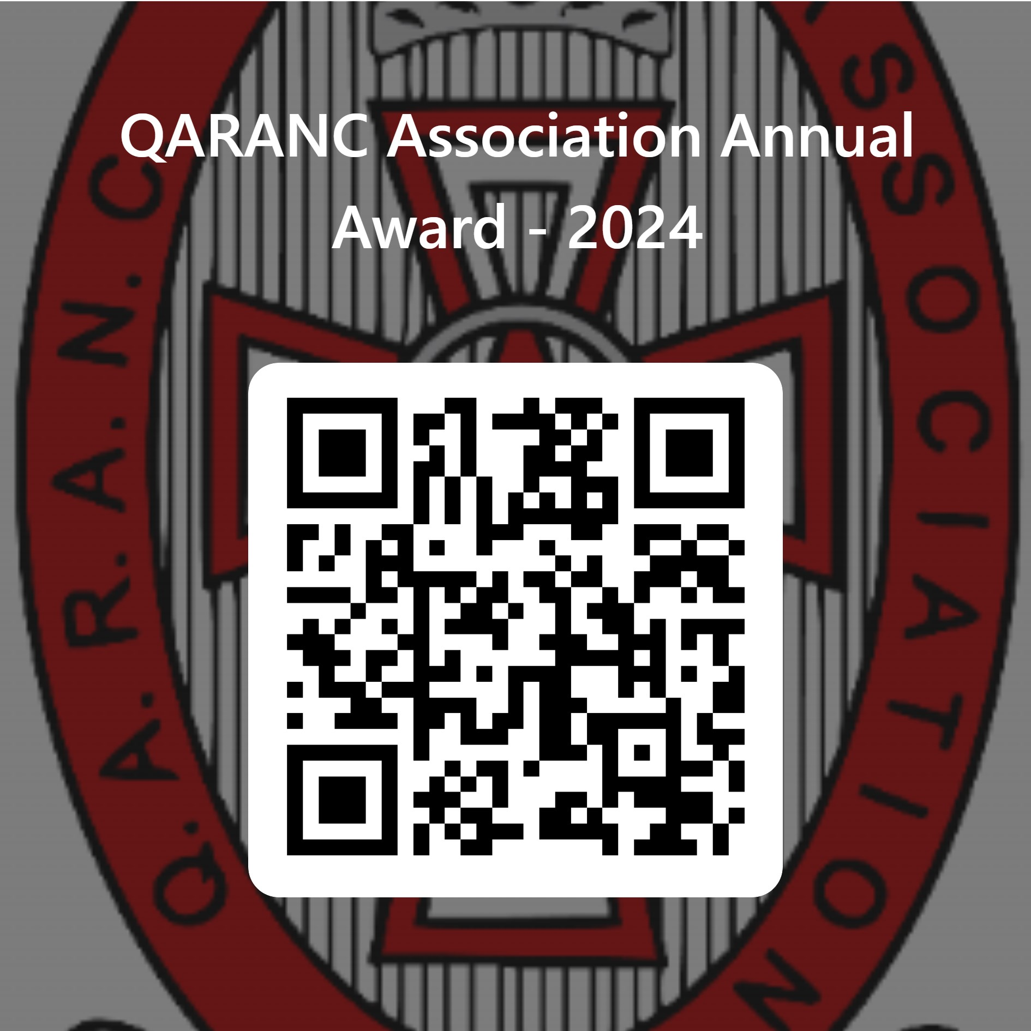

5. For those without IT please complete the form at Annex A.

Guidance

6. When writing your citation please concentrate on the nominee’s activities in the QARANC Association, the benefits they have brought to the Association and what makes them standout above the rest. Please provide specific examples.

Selection

7. Members of the Board of Trustees will convene to select the successful nominee. The award winner will be announced on Sat 27 Apr 24.

8. We look forward to hearing some wonderful examples of how QAs support each other. If you require any further information, then please contact Tracey Buckingham manager@qarancassociation.org.uk

With Best Wishes

John Quinn

John Quinn OStJ
Chair QAA Board of Trustees

Distribution:

All QARANC Association Branches
Chair
Vice Chair
Administration Officer

Annex

A. QARANC Association Annual Award 2024 – Nomination Form (non electronic).

QARANC Association Annual Award 2024 – Nomination Form

Please only use if you cannot complete MS Forms

Nominee Name
Nominator Name & Branch
Guidance | When making your recommendation please concentrate on the nominees’ activities in the QARANC Association, the benefits they have brought to the Association and what makes them standout above the rest.  The Association will not be contacting unsuccessful nominees. Completed forms are to be sent to the manager@qarancassociation.org.uk Max: 500 words

