WELSH BRANCH CORPS DAY 6TH APRIL 2025
QARANC Corps Day Celebration
Driving along the A470 on a beautiful spring morning, Pen-y-Fan and the Bannau Brycheiniog looked absolutely stunning in the early sunshine. We made our way to Llanharry to meet up with fellow members at Rosy’s before continuing on to Llantrisant Parish Church for our QARANC Corps Day celebration, thoughtfully organised by our Chair.
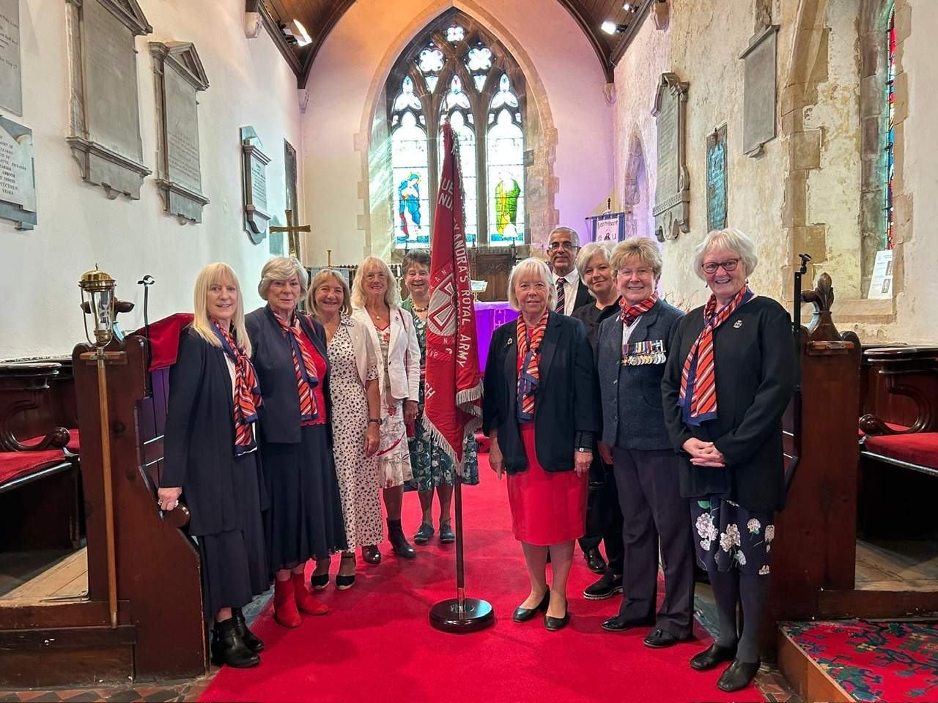

Llantrisant Parish Church, is an ancient and atmospheric
building, dedicated to three saints St Illtyd, St Gwynno
and St Dfodwg provided the perfect setting. The
Reverend Vincent Gardiner warmly welcomed us,
and the service focused on our Corps Day. It included
a heartfelt mix of hymns, the QARANC poem, the Collect
and Army Nurse Prayer, a prayer for those deployed on
active service, and a prayer for the Armed Forces of the
Crown, as well as information on Lent and Passion Sunday. It was a lovely, joyous service.
After the service, we had the opportunity to explore the church,
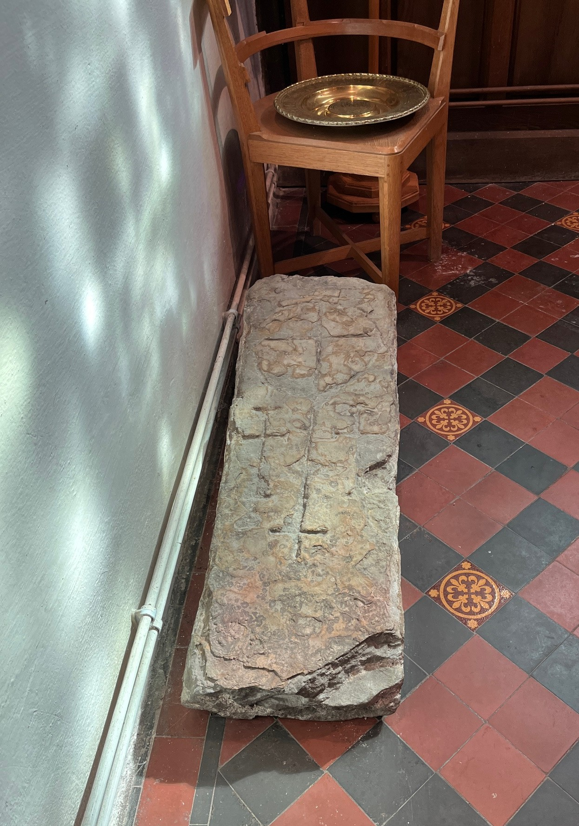
including a visit to its oldest artefact – The Resurrection Stone –
believed to date back as far as the 7th century.
The east window features a stained-glass picture of the crucifixion
depicting a beardless Christ .

We then enjoyed coffee, cake, and custard creams
while chatting with members of the congregation.
Many were interested in learning more about the QARANC, our
roles, and our service, with some sharing that they had relatives who had served in the Corps.
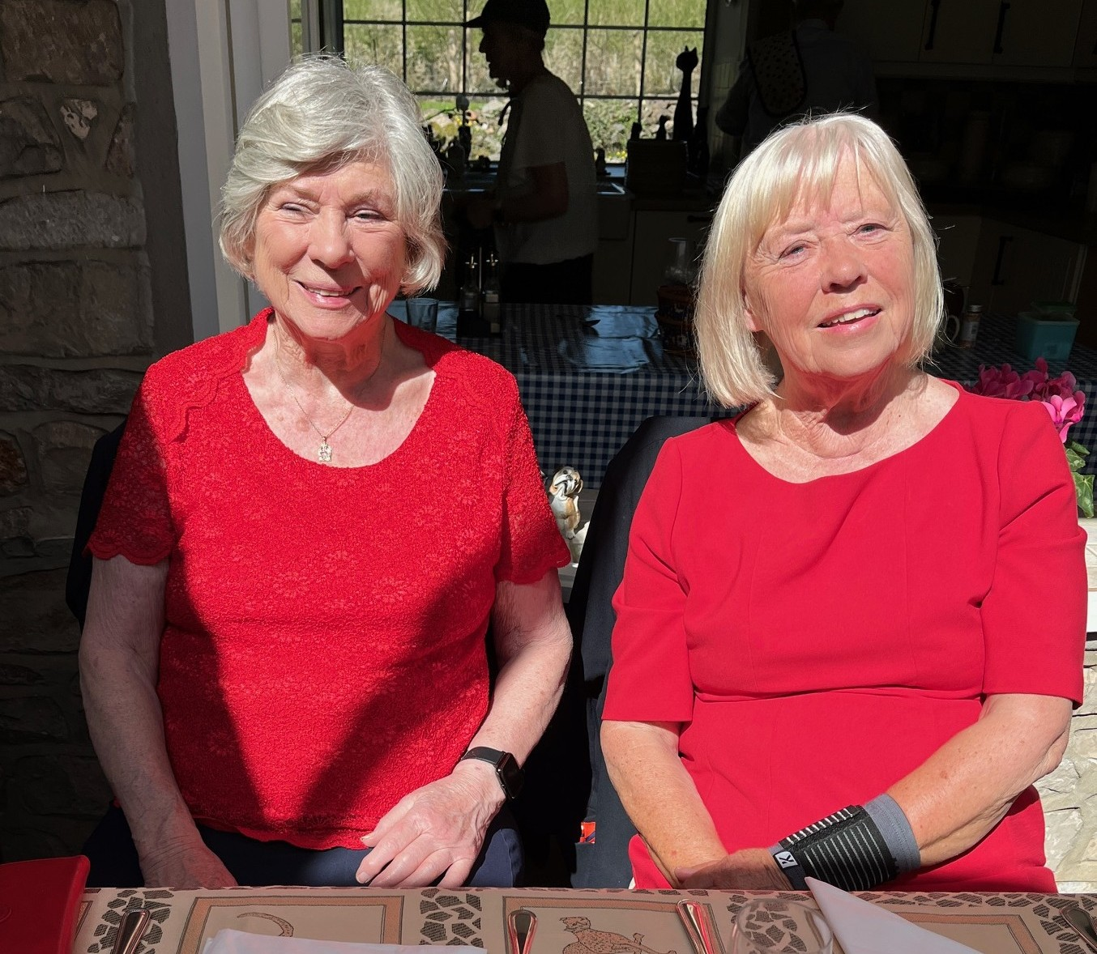
Then it was time to return to Rosy’s for lunch. There was
plenty of time beforehand to catch up with other members
and enjoy each other’s company. Lunch was delicious – the
chocolate trifle, in particular, was definitely “naughty but
very nice!”
All too soon, it was time to say our goodbyes and head home.

What a lovely day it had been - a joyous church service with the QARANC proudly at the heart of it, followed by a wonderful lunch full of chatter, laughter, and new connections.
A heartfelt thank you once again to Rosy and Phil for organising such a special day.

