Information QA ASSOCIATION website Welsh Branch January 2021
History of the Welsh Branch

The beginning

The Welsh branch was formed and held their inaugural meeting on the 20th April 1968, at Ty Maeth the home of the Welsh Board of royal college of nursing. There were 14 members in attendance.
The group were made up of serving and retired personnel and members of Territorial Army Voluntary Reserve (TAVR). During the meeting the name of the branch was agreed as “The Welsh Branch of the QARANC Association”. Publicity, finance details and future meetings were discussed. The branch was initially financed a £10 loan by QARANC Association HQ and the Commanding Officer of 203 (Welsh) General Hospital TAVR offered the hospitality of the Territorial Army centre at Llandaff for future branch meetings.
The branch has always observed the aim of the Association in being a benevolent society looking after its members and offering friendship.
This section will continue to be updated in future website updates.
Today we continue the relationship with 203 (Welsh) Field Hospital with many present and past personnel being members of the branch.
QARANC Association Medal

The QARANC Association Medal awarded annually to the QARANC Association retired member who has made an outstanding contribution to the Association by fostering esprit de corps, comradeship and the welfare of the Corps by preserving its traditions of reliving need, hardship or distress.
The Welsh Branch was delighted that our Branch Secretary Major (Retd) Rosy Hubbard TD was a recipient in 2020.
Pictured left Rosy Hubbard (Maj rtd)
Recipient of QARANC Medal 2020

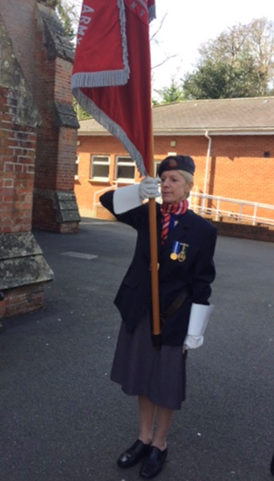
Rosy is the standard bearer for the branch and represents the Corps and Branch at various functions.

Within the Welsh Branch we have 3 serving or retired reservist nurses who hold the Royal Red Cross (RRC) and Order of St John (OStJ). The Royal Red Cross medal (or more accurately decoration) was introduced to Military Nursing by Royal Warrant by Queen Victoria on 23rd April in 1883 which was St George's Day. The decoration is awarded to army nurses for exceptional services, devotion to duty and professional competence in British Military Nursing.
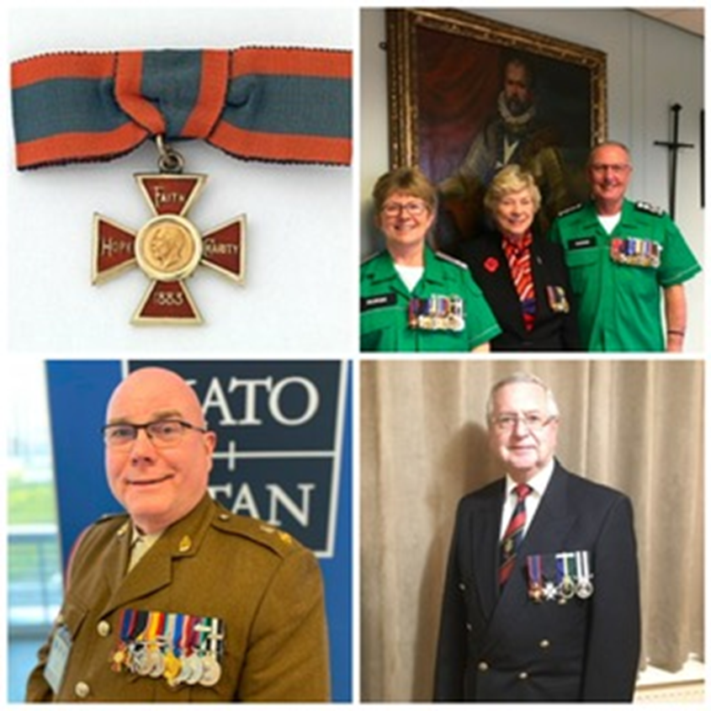
(L to R) Lt Col Caroline Whittaker, Lt Col Marilyn Williams and Col Kevin Davies

Communications with branch members

In the spirit of friendship, the branch undertakes numerous face to face and online events. Due to the pandemic, technology has provided us with a way not only to be in contact with each other, for example see each other, the Christmas zoom where we all wore Christmas jumpers etc a glass of something and a mince pie.

These get togethers allow the members to share what they have been doing during lock down. Humour and laughter and ability to see other group members being a major component of the sessions. It has also allowed group support to individuals as necessary.
The committee has continued to support members throughout the year with flowers, phone calls, emails etc as necessary. In the branch we have older QA’s who live on their own, many with few or no family, others with ill health. Maintaining communication with these members is one of the Corps main aims of “caring for each other” and has been much appricated by members concerned.

Christmas Gift

In the Spirit of Friendship and to support the members and the generosity of HQ QARANC Association and Branch Funds each member received a Christmas gift and card.

Museum of Military Medicine

On the 17th December 2020 the exciting news that Cardiff City Council had approved planning permission for the Museum to be located in Cardiff Bay was approved. As a branch we look forward to future developments as they progress. And to support the museum in any way the Branch can.

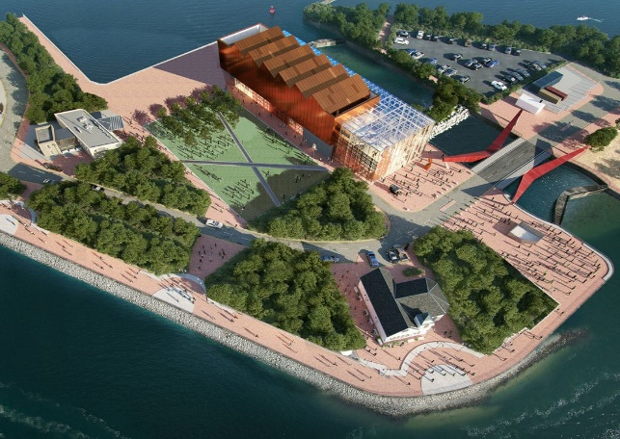

Events

On the 22nd January Maj. Eirian Davies 203 Fd Hospital/Care Manger of the Blind Veterans UK Centre Llandudno. Gave us a very interesting and informative talk on the role of BVUK via Zoom. Covering the initial concept of looking after and rehabilitating soldiers returning from the western front in 1915 following gas attacks resulting in blindness and eye injuries. To the injuries experienced in conflicts to the present day. Discussing research that is ongoing into various elements of reduced vision or blindness. BVUK is accessible to all veterans

Dates for your diary 2021

June 26th Armed Forces Day High Tea with Music at Caroline’s
July 14th Lavender farm visit and walk, option of less strenuous Garden Centre visit, all followed by food at Pilgrim’s Café Brecon Cathedral.
September 30th Canal Boat trip form Goytre Wharf Llanover, Abergavenny
November 6th Festival of Remembrance St David’s Hall Cardiff
November 14th Remembrance Parades.
November 23rd Cooking Demo & Lunch Gareth’s kitchen Lampeter
December 3rd Christmas Lunch Radyr Golf Club
Proformas and Joining instructions will following nearer the events

